CptS 540 Artificial Intelligence

Kondyrev Andrei

09/15/2021

Assignment 3

1. a

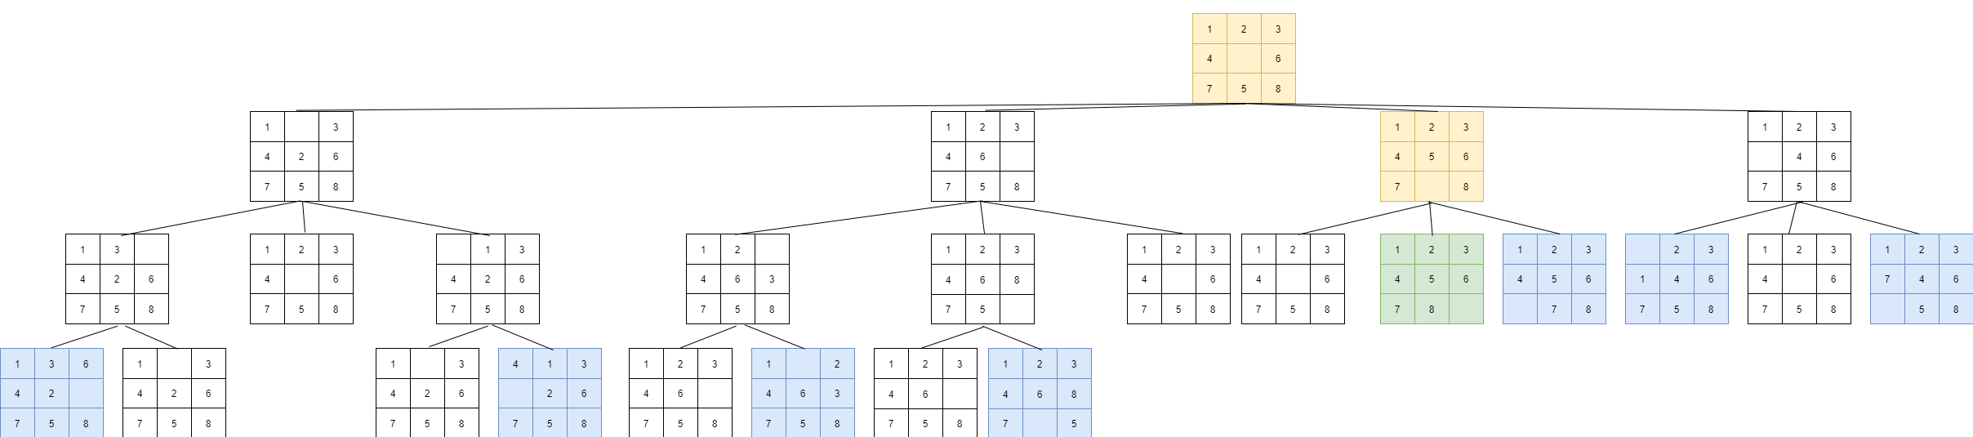

1. b

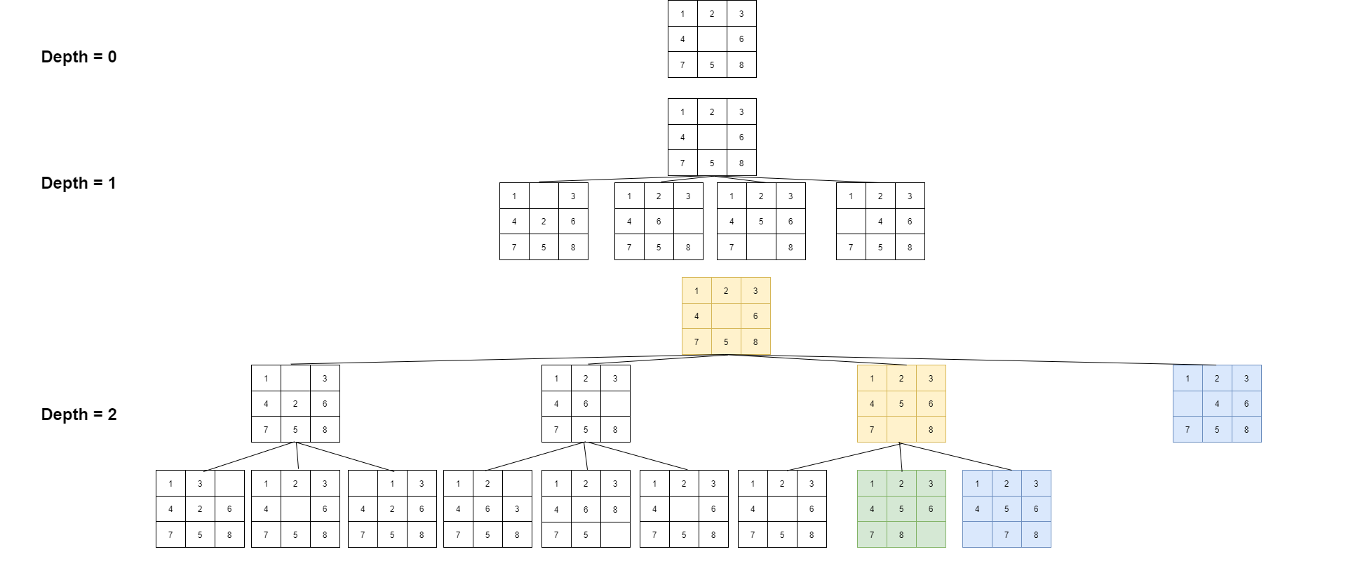

1. c

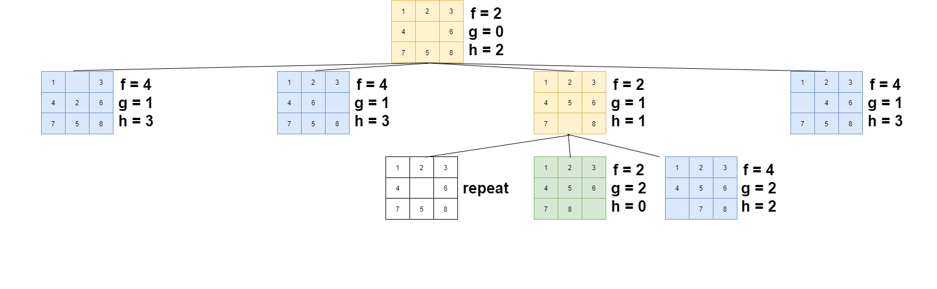

1. d

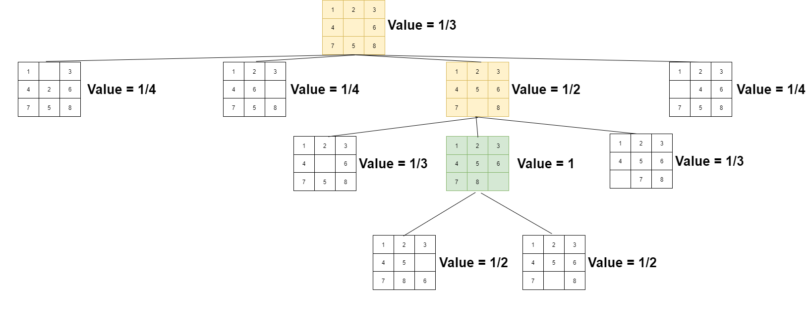

3. a. If we subtract 1 from CityBlock Distance our final function will not get to the solution. It will be one depth above the solution because the heuristic will be equal to zero and by the definition Informed search has h(G) of a goal node equal to zero. So my guess is that CityBlock Distance – 1 is not an admissible heuristic.

3. b. By the definition the heuristic function is admissible if: $0 ≤h\left(N\right)≤h^{*}(N)$, where $h^{*}(N)$ is the cost of the optimal path from N to a goal node. Admissible heuristic function should always be optimistic.

If we add 1 to CityBlock Distance our goal node heuristic will be equal to 1 and we won’t be able to get it below that because every step from the goal node will make the heuristic bigger than 1. This heuristic is not optimistic.

But if we are talking about Hill-Climb algorithm, it will converge at some point because as I understood correctly, it doesn’t rely on h(N) to be equal to zero. At some point it will eventually get to a point of local/global maximum and will stop there because the last point’s neighbors will be less due to a relation of 1/h(N). Value of the global maximum point will be 1 and it’s neighbors will have value of ½.

However in general this heuristic won’t be admissible too.